Practical-3
Name:- Shubham Sonawane
Roll no-4401058
Div-A Batch-D
3rd experiment (yash cha Ultrasonic sensors wala)
#define BLYNK_TEMPLATE_ID "TMPL36jrZnpQh"
#define BLYNK_TEMPLATE_NAME "Interfacing Sensors And Actuators With ESP8266"
#define BLYNK_AUTH_TOKEN "b_aZa5wq5V5MUnIa4ad9M6RX698hIA33"
#include <ESP8266WiFi.h>
#include <BlynkSimpleEsp8266.h>
#include <LiquidCrystal_I2C.h>
// --- WiFi Credentials ---
char ssid[] = "OnePlus 11R 5G";
char pass[] = "YBorse5029";
// --- LCD Setup (I2C) ---
LiquidCrystal_I2C lcd(0x27, 16, 2); // Adjust address if needed
// --- Pin Configuration ---
#define trigPin D5
#define echoPin D6
#define irPin D7
#define tempPin A0
// --- Variables ---
long duration;
int distance;
int irValue;
float temperature;
// --- Timer for Blynk ---
BlynkTimer timer;
// --- Function to read sensors and update LCD/Blynk ---
void readSensors() {
// --- IR Sensor ---
int rawIR = digitalRead(irPin); // LOW = object detected (depends on module)
if(rawIR == LOW) irValue = 1; // Object detected
else irValue = 0; // No object
Blynk.virtualWrite(V2, irValue);
// --- Ultrasonic Sensor ---
digitalWrite(trigPin, LOW);
delayMicroseconds(2);
digitalWrite(trigPin, HIGH);
delayMicroseconds(10);
digitalWrite(trigPin, LOW);
duration = pulseIn(echoPin, HIGH, 30000); // 30ms timeout
if(duration == 0) distance = 0; // No echo detected or object too close
else distance = duration * 0.034 / 2; // Convert to cm
// Limit max distance to avoid showing huge numbers
if(distance > 400) distance = 400;
Blynk.virtualWrite(V1, distance);
// --- Temperature Sensor (LM35) ---
int adcValue = analogRead(tempPin);
float voltage = adcValue * (3.3 / 1023.0); // ESP8266 ADC ref = 3.3V
temperature = voltage * 100; // LM35: 10mV per °C
Blynk.virtualWrite(V0, temperature);
// --- Update LCD Display ---
lcd.clear();
lcd.setCursor(0, 0);
lcd.print("D:");
lcd.print(distance);
lcd.print("cm ");
lcd.print("IR:");
lcd.print(irValue);
lcd.setCursor(0, 1);
lcd.print("T:");
lcd.print(temperature);
lcd.print("C");
// Optional: Send LCD text to Blynk (V3)
String lcdData = "D:" + String(distance) + "cm IR:" + String(irValue) + " T:" + String(temperature) + "C";
Blynk.virtualWrite(V3, lcdData);
}
void setup() {
Serial.begin(9600);
// --- LCD Init ---
lcd.init();
lcd.backlight();
// --- Pin Modes ---
pinMode(trigPin, OUTPUT);
pinMode(echoPin, INPUT);
pinMode(irPin, INPUT);
// --- Connect to Blynk ---
Blynk.begin(BLYNK_AUTH_TOKEN, ssid, pass);
// --- Run readSensors() every 1 second ---
timer.setInterval(1000L, readSensors);
}
void loop() {
Blynk.run();
timer.run();
}

OUTPUT:
Blynk IOT Dashboard -
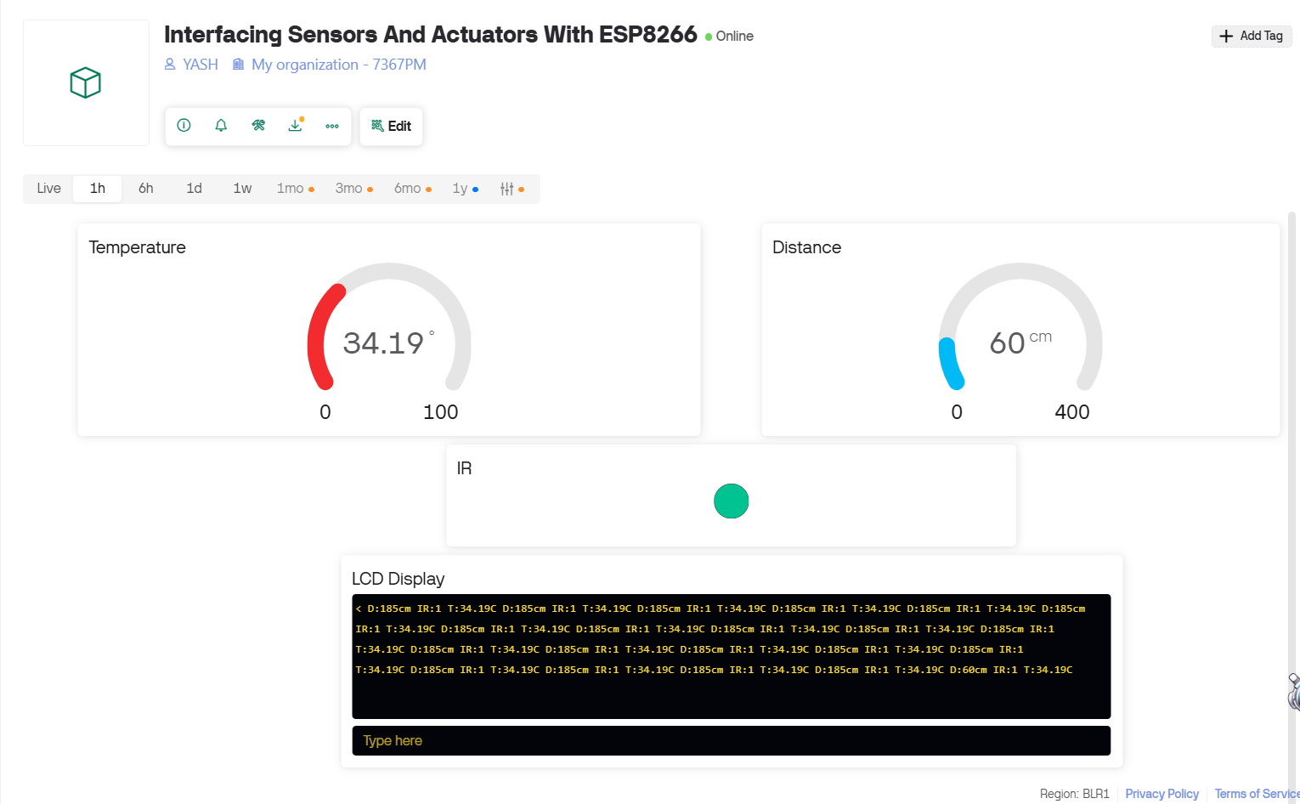
Hardware Output:
